Honiton and District Lions Club

Meetings on the 2nd and 4th Tuesday of each month at 7.15pm for 7.30pm at The Deer Park Country Hotel, Weston

Formed in 1977, the club is one of similar groups in Devon, Cornwall and Somerset. Within the British Isles and Ireland 18,000 members and worldwide 1.35M members, 45,000 clubs in 206 countries

You always have friends worldwide

Being a “member” or “friend” provides you with the opportunity to assist others in a way that no one person could do

Our administrative costs are covered by club subscription. Funds for charity are always kept separate and distributed directly to the area in need.

LIONS ARE PEOPLE…… .......JUST LIKE YOU
MEMBERSHIP IS OPEN TO ANYONE
Prepared to dedicate some spare time to community service

AND HAVE FUN DOING IT

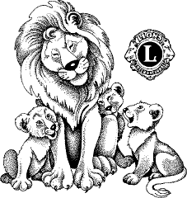

There is no compulsion to join

Nothing to stop you leaving…

For more information CALL / E-Mail
THE LARGEST SERVICE ORGANISATION IN THE WORLD

FIND OUT
WHAT LIONS


ARE ALL ABOUT

Honiton and District Lions Club

Working in and serving the community

Could you become a
FRIEND OF LIONS or
Member of the LIONS
FRIENDS OF LIONS

What are FRIENDS OF LIONS?
Mainly enjoying the social side

If assisting others appeals to you, yet you do not wish to make a “fulltime” commitment to membership, for £5 a year we will keep you informed by E-Mail monthly about what we are doing. There are NO meetings to attend and you can be involved as much or as little you feel able.
You are welcome to attend any of the social functions, dinners / skittles / walks / quizzes or fund raising events at any time.

Submitting a charitable request
As a “Friend” you are free at anytime to request and attend a meeting or forward a suggestion with reference to a good local cause, which will be considered.

MEMBER OF LIONS

The Club has about 20 members from all walks of life and backgrounds, united in a common aim – to help those less fortunate than themselves.

Lions are people who give something back to their communities

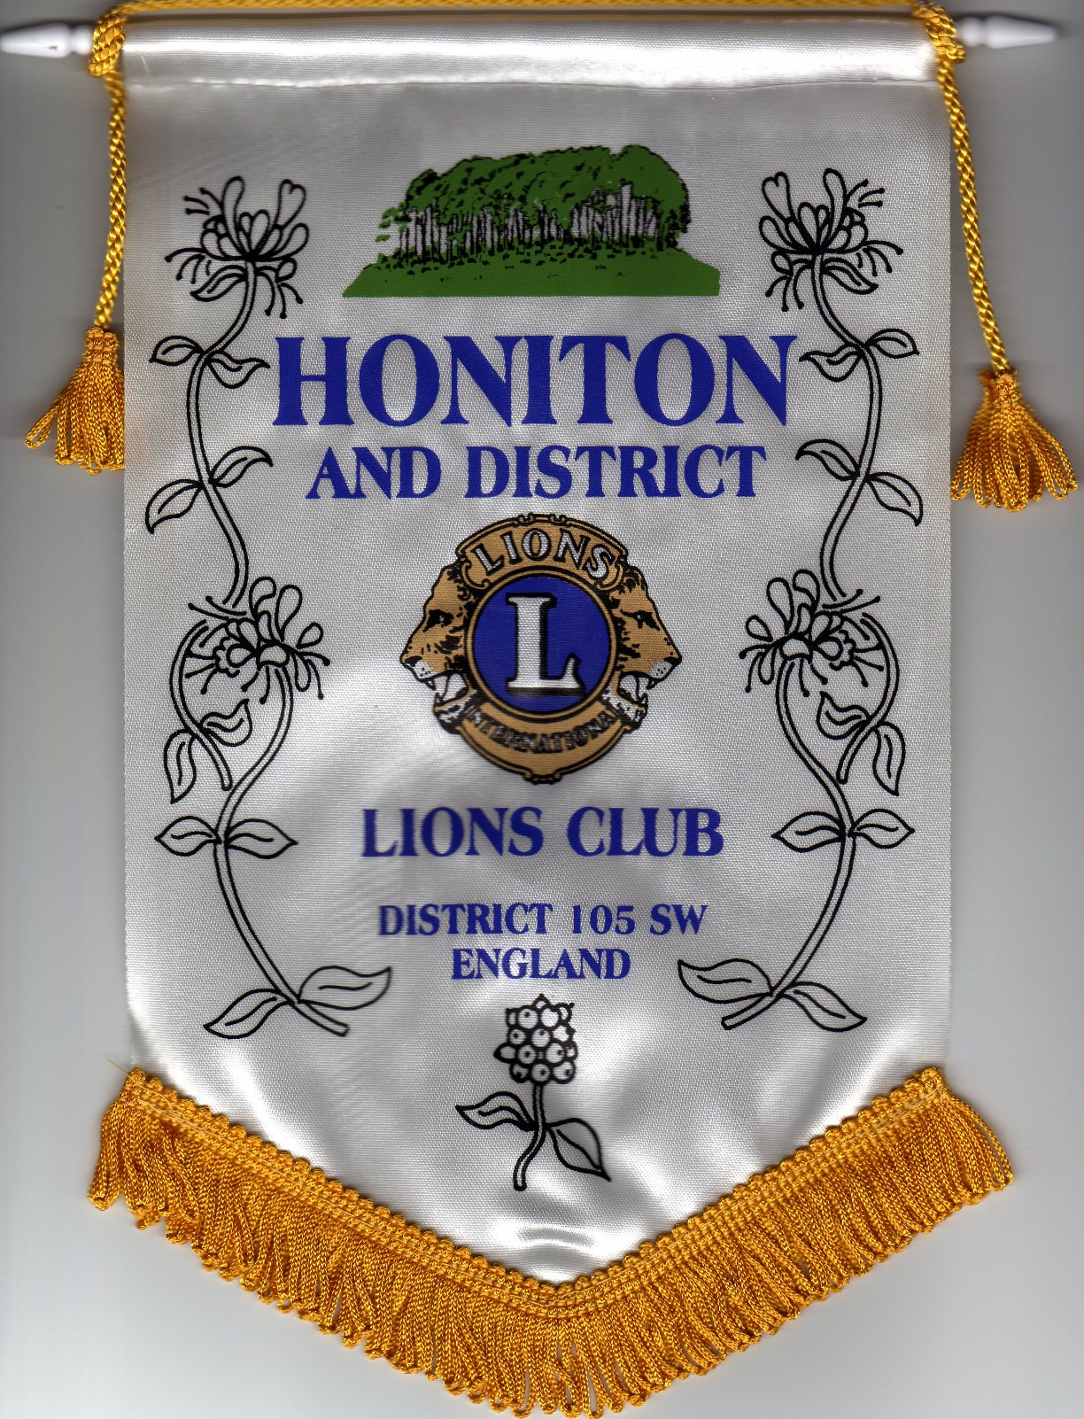
Meeting twice a month to agree fund raising plans / review charitable requests

Help local voluntary community organisations through “hands-on” assistance, purchase of equipment, etc.

Lions are people who enjoy themselves and include fun in their caring attitude

Selection of Local charities / people supported

Devon Freewheelers
Honiton Community Collage
Chestnut Appeal
Busy Bee Pre-School Honiton
Devon Air Ambulance (DAAT)
Boscastle flood Disaster
Local student with Tall Ships race
Children’s Guides and Scout Groups Hospice South West

Honiton Army Cadets and ATC
Honiton Cricket, Football and Rugby Clubs (Youth Teams)

Fund raising events

Our events such as “The annual Duck Race, Wheel barrow and contents raffle, Tar barrel BBQ stand in Ottery St. Mary” etc would not be successful in raising funds without the support of the local community or, of course, the members of the Lions club.

Sponsor “message in a bottle” scheme

